School Strategic Plan 2019-2023
Kyneton High School (7970)

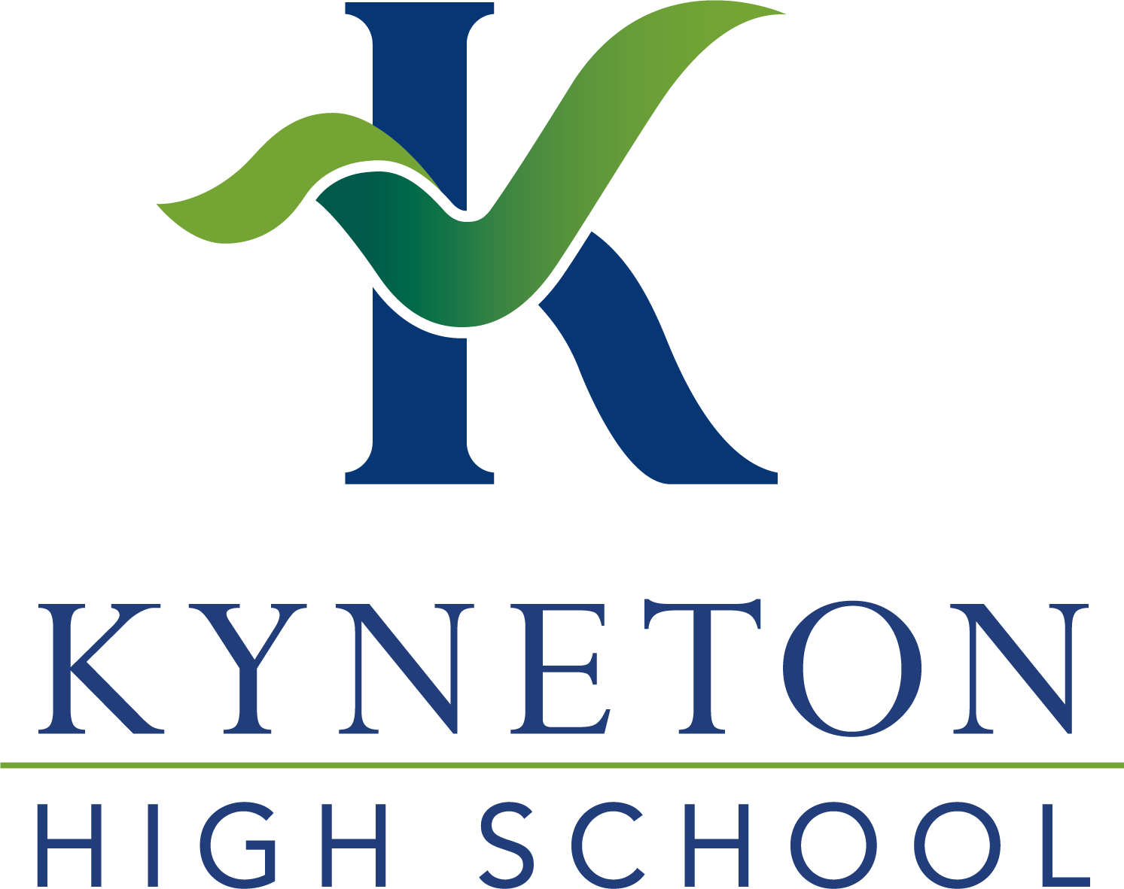
Submitted for review by Ana Rees (School Principal) on 20 August, 2020 at 02:43 PM
Endorsed by Christopher Eeles (Senior Education Improvement Leader) on 15 September, 2020 at 11:55 AM
Awaiting endorsement by School Council President
School Strategic Plan 2019-2023
Kyneton High School (7970)

School vision | Kyneton High School is committed to building a Learning Community based on positive relationships and a strong work ethic, where people are able to realise their potential in a safe, caring, stimulating and sustainable environment.  We work in partnership with our community to prepare students for their futures as responsible, successful adults. We strive for excellence, developing confidence and embracing diversity in a respectful, sustainable environment.
School values | The four school values are:  Respect - caring, communication, compassion, consideration, integrity, self-worth  Diversity - inclusion, acceptance, empathy, equity, openness, safety  Excellence - ambition, courage, creativity, enthusiasm, learning success  Sustainability - accountability, perseverance, pride, reflection, resilience, responsibility
Context challenges | The college data showed that improving student levels of achievement in NAPLAN and VCE needed to be a focus of the next SSP. Aligned with the newly developed college vision, it was considered that the college needed to use collaborative processes to develop a consistent approach to curriculum, pedagogy and assessment processes to ensure that strategies such as the use of the instructional model and high impact teaching strategies were used consistently, and that the curriculum at all year levels was appropriate to the needs of all students including high achieving students, students with special needs and VCAL students, with a view to improving student achievement levels.  Analysis of the Student Attitudes to School Survey showed that student engagement in learning was below expected levels. Similarly, absence rates were above expected levels. It was determined that the college needed to create a positive learning environment, and to develop strategies, such as Student Voice and Agency, to enhance student engagement in the classroom and in other school activities.  Discussions during the school review provided evidence that the student wellbeing program was comprehensive, but it was felt that a school–wide approach to wellbeing was needed, and that clear communication processes were required to ensure the success of the program.
Intent, rationale and focus | To improve outcomes for all students we will consistently implement high quality teaching and learning programs across the entire school. We will improve student engagement in their learning by ensuring that the capabilities of all students are being considered when developing classroom curriculum and practices. We will ensure that students are able to thrive within a safe, inclusive and positive climate for learning. All staff will have access to high level professional learning and engage in collaborative professional teams that focus on improving outcomes for all students. Staff performance and development will be linked very tightly with this stated intent.  The focus of our improvement priorities will be on:  • Achieving excellence in teaching and learning with emphasis on building practice excellence and curriculum planning and assessment  • Creating a positive climate for learning through empowering students, building school pride and creating a culture of high expectations amongst staff, students and parents.  • Building and empowering staff and student leadership teams around a common set of vision, values and culture.  • Increasing our community engagement in learning.

School Strategic Plan 2019-2023
Kyneton High School (7970)

Goal 1 | To improve student achievement in all subjects at all year levels
Target 1.1 | Increase the mean VCE All Study Score from 25.94 (2018) to 28 (2022)  Increase the mean VCE English Study Score from 25.68 (2018) to 28 (2022)
Target 1.2 | Increase the percentage of students with high and medium Years 7-9 growth in NAPLAN in:  - Reading from 71% to >=75% (2022)  - Writing from 65% to >=75% (2022)  - Numeracy from 60% to >=75% (2022)
Target 1.3 | For all subjects, increase the percentage of students with high and medium growth in teacher judgements to at least 75%
Target 1.4 | By 2022, the Collective Efficacy scale of the SSS will increase from 27 per cent positive (2018) to 50 per cent positive (2022)
Key Improvement Strategy 1.a  Building practice excellence | Implement a collaborative structure to enhance student achievement, engagement and wellbeing
Key Improvement Strategy 1.b  Building practice excellence | Develop data literacy and the explicit use of evidence-based, high impact strategies
Key Improvement Strategy 1.c  Curriculum planning and assessment | Improve and align curriculum planning, teaching and assessment practices
Key Improvement Strategy 1.d  Evaluating impact on learning | Action Plan to accelerate improvement
Goal 2 | To improve student engagement for all students
Target 2.1 | By 2023, student absences will decrease from 29.21 days per student per year (2018) to 25 days per student per year
Target 2.2 | By 2022, the percentage of positive responses on the student AToSS for:  - Student Voice and Agency will increase from 37% (2019) to 60%  - Classroom Behaviour will increase from 51% (2019) to 65% (2022)
Key Improvement Strategy 2.a  Setting expectations and promoting inclusion | Development and implementation of a culture of inclusion at the college
Key Improvement Strategy 2.b  Empowering students and building school pride | Development and implementation of a Student Voice and Agency strategy
Key Improvement Strategy 2.c  Empowering students and building school pride | Creation and implementation of a positive environment for learning
Goal 3 | To improve student wellbeing
Target 3.1 | By 2022, the percentage of positive responses on the student AToSS for:  - Respect for Diversity will increase from 40% (2019) to 60%  - Teacher Concern will increase from 41% (2019) to 60%
Target 3.2 | By 2022, the percentage of positive responses on the School Staff Survey scale of Staff Psychological Safety will increase from 32.1% (2018) to 60%
Key Improvement Strategy 3.a  Health and wellbeing | To develop and implement a school–wide wellbeing strategy

